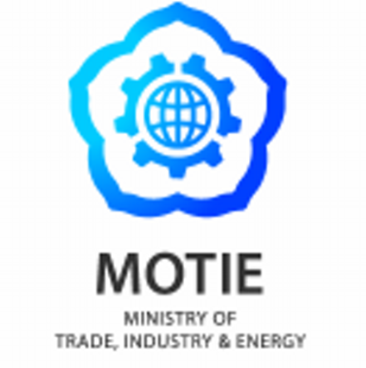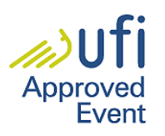
The One & Only Show in Welding Capital of Korea
WELDING KOREA 2016 Buyer Application

*Please write in English
Company |  | Establishment  Year
E-mail |  | Tel.
Website |  | Fax.
Address
Annual Sales  (2014 or 2015) |  | No. of  Employees
Nature of  Business | □ Imp. □ Exp. □ Mfg. □ Distributor □ Wholesaler □ Retailer
 | □Agent □ Service Company □ Trade Org. □ Government □Others
Current Vendor(s)
in Korea
Expected date of visit to Korea *Hotel check-in/out date
(exhibition period: 2016. 10 11~10. 14)
: 2016/ __________/ __________ ~ 2016/ __________/ __________ (month/day)
Visitors | Name / Position | Phone | E-mail
Products | Products(s) willing to  purchase from Korea | Description | Quantity or Amount  (in US$) (expected)

2016. __________(month). __________(day)
Name: ____________________ (signature)

Secretariat
E-mail: eskimofriend@coex.co.kr Tel: +82-55-212-1015 http://www.weldingshow.co.kr
Address: CECO administration, 362 Wonidaero, Uichang-gu, Changwon-si, Gyeongnam, Korea

